**SQL ANALYSIS**

1. **I ensured the entire data set was loaded into pg admin4 and checked the row**

**SElECT** **COUNT**(**\***) **AS** Complete NO_OF_RECORDS

**FROM** hotel_bookings

Complete NO_OF_RECORDS: 119390

**2.What is the cancellation rate for each hotel type**

SELECT hotel,   
     ROUND(AVG(is_canceled), 3) AS CANCELLATIONS  
FROM hotel_bookings  
GROUP BY hotel;

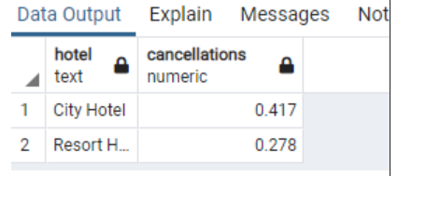

**3.Most common customertype**

**SELECT** customer_type, **COUNT**(**\***)

**FROM** hotel_bookings

**GROUP** **BY** customer_type

**ORDER** **BY** **COUNT**(**\***) **DESC**

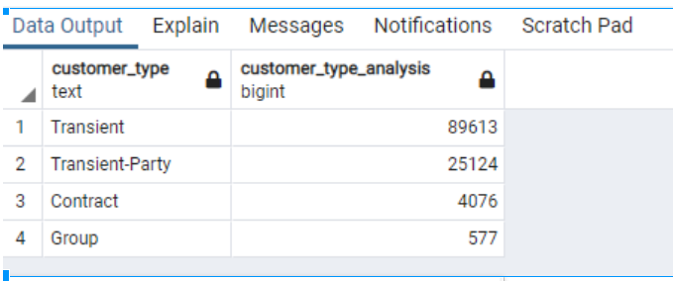

**4. Most common country of guests?**

In [12]:

SELECT country, COUNT(*) as relevant_countries  
FROM hotel_bookings  
GROUP BY country  
ORDER BY COUNT(*) DESC  
LIMIT 3

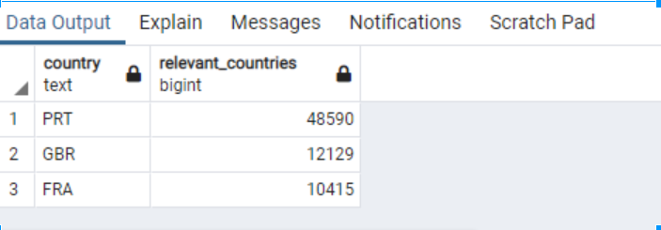

**The most engaging month**

SELECT arrival_date_month, COUNT(*) AS reservationsforme  
FROM hotel_bookings   
GROUP BY arrival_date_month  
ORDER BY reservationsforme DESC

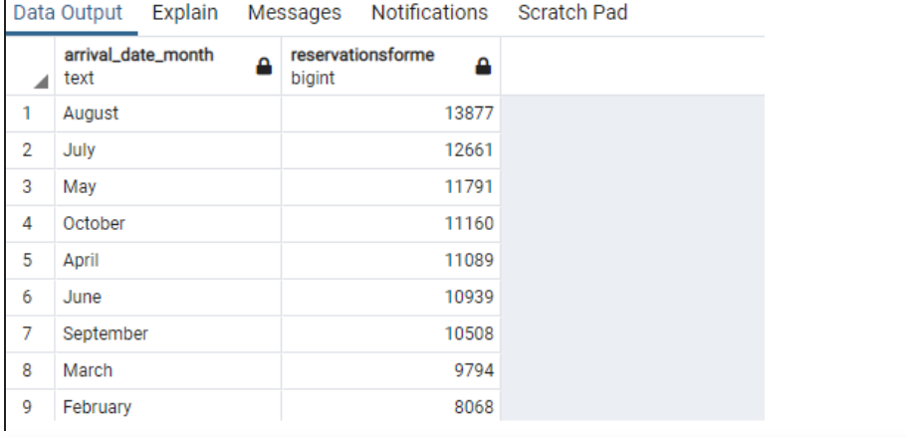

**5. Are the guests that reserve new or repeated**

In [15]:

**SELECT** is_repeated_guest, **COUNT**(**\***) **AS** guests_count

**FROM** hotel_bookings

**GROUP** **BY** is_repeated_guest

